**To Supply Leftover Food to Poor**

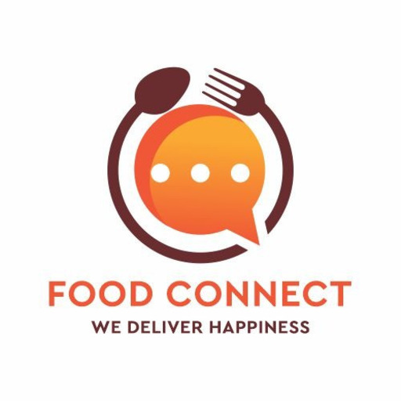B.Jahnavi

[bommujahnavi2@gmail.com](mailto:bommujahnavi2@gmail.com)

Annamacharya Institute of Technology and Sciences

Rajampet.

# **Project Overview**:

The project **“To Supply Leftover Food to the Poor”** aimstobridge the gap between food waste and hunger by creating a centralized platform that connects food donors – such as restaurants, hotels, and households with NGOs and volunteers who can collect and distribute the food to those in need. By enabling real-time alerts, pickup scheduling, and donor tracking, the system ensures timely and efficient food redistribution. It helps reduce food wastage while supporting the underprivileged with regular meal access. The platform leverages salesforce features for user management, automation, and reporting to ensure transparency and accountability. It also provides dashboards to track donations, monitor delivery status, and measure impact. The project’s core objective is to minimize food waste and support hunger eradication through smart coordination and collaboration.

# **Objectives:**

## Reduce food Wastage:

* **Redirect surplus edible food** from restaurants, hotels, and events to the underprivileged instead of letting it go to waste.
* **Create an organized donation process** using Salesforce to ensure timely collection and distribution before the food becomes unusable.

Streamline Food Donations:

* **Allow donors to easily register and log food donations** through a user-friendly Salesforce interface.
* **Automate donation workflows** to match available food with nearby NGOs or volunteers for quick pickup and delivery.

Enable Real-Time Coordination:

* **Send instant notifications** to nearby NGOs or volunteers when a food donation is posted on the platform.
* **Use Salesforce automation tools** to schedule and assign pickups based on location, availability, and urgency.

Track and Monitor Activities:

* **Utilize Salesforce dashboards and reports** to monitor food donations, pickups, and deliveries in real time.
* **Maintain detailed records** of donors, recipients, and distribution timelines for transparency and accountability.

Support NGOs and Volunteers:

* **Provide a centralized platform** for NGOs and volunteers to manage donation requests, pickups, and delivery status.
* **Enable communication and task assignment** through Salesforce tools to ensure efficient coordination and resource allocation.

Ensure Food Safety and Quality:

* **Track pickup and delivery times** to ensure food is collected and distributed within safe consumption periods.
* Allow donors to specify food type, quantity, and expiration details to help NGOs assess suitability before collection.

**Requirement Analysis & Planning**:

* Understanding Business Requirements:

This CRM system is designed to connect food donors (restaurants, hotels, individuals) with NGOs or volunteers who can distribute leftover food to underprivileged communities. Key user needs include:

* **Donors** need an easy way to log and track leftover food donations.
* **NGOs/Volunteers** need access to real-time data on food availability and location.
* **Administrators** need insights, tracking, and control over donations and deliveries.
* **Transparency** in the food distribution process is crucial to ensure trust and compliance.
* Problems being solved:
* Food wastage in restaurants and households.
* Hunger and food insecurity among the poor.
* Lack of a centralized, automated matching and tracking system for food donations.
* Defining Project Scope and Objectives:

**Scope:**

* Development of a Salesforce CRM platform that includes donors, NGOs, volunteers, and admin roles.
* Real-time notification system for food availability and pickup scheduling.
* Record management of donations, beneficiaries, and delivery history.
* Role-based access for different user categories.
* Reports and dashboards for tracking donation trends and impact.

**Objectives:**

* Minimize food wastage by efficiently collecting surplus food.
* Maximize the reach to the poor by coordinating with multiple NGOs/volunteers.
* Enable data-driven decisions through analytics.
* Ensure data security, audit trails, and system integrity.
* Create a scalable, mobile-friendly system accessible to all stakeholders.

**Salesforce Development - Backend & Configurations**

1. Environment Setup :

Setting up the Salesforce environment is a crucial foundational step to ensure a stable, scalable, and secure development and deployment process. The setup begins with configuring different types of environments, such as Developer Sandbox for building features, and Partial Copy or Full Sandbox for testing and validation. These isolated environments prevent disruptions in the production system while allowing developers and administrators to test new functionality thoroughly. Salesforce's metadata-driven architecture allows for customization and configuration across objects, fields, and automation components, which must be consistently managed in a structured environment. Version control tools like Git are essential for tracking changes, enabling collaboration among multiple developers, and supporting rollback when needed. DevOps tools such as Salesforce CLI (SFDX), ANT Migration Tool, and CI/CD integrations help automate deployments and ensure quality assurance across environments. Proper environment setup also involves enabling debug logs, setting up user roles and profiles, and activating essential features like field history tracking and audit trails. This setup guarantees that the application is secure, compliant, and robust before it's released to production. Ultimately, a well-configured Salesforce environment not only supports efficient development and testing but also improves deployment reliability and long-term system maintenance.

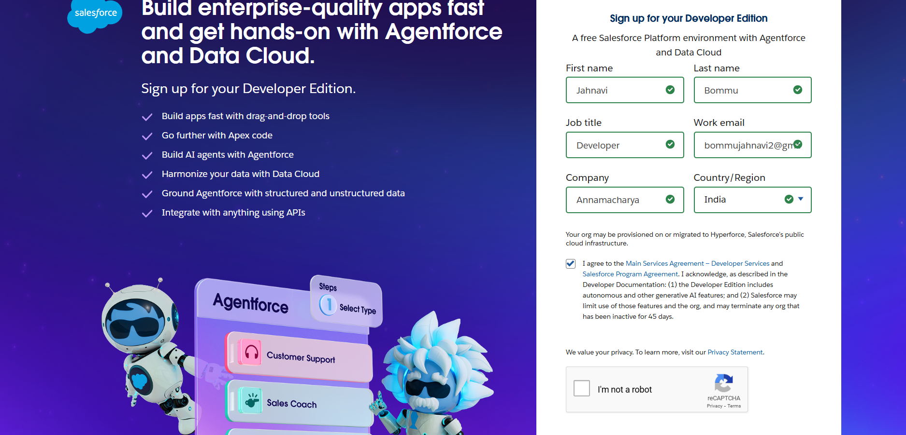

**2**.**Customizations:**

Objects:

* Venue:

The Venue__c object represents the location where food donations are either made or collected. It plays a critical role in geographically organizing donations, coordinating pickups, and helping volunteers and NGOs identify nearby opportunities. In the Food Connect system, a Venue could be a restaurant, a hotel, a community kitchen, or even a temporary donation camp.

The Venue__c object adds a crucial **geospatial and operational dimension** to the Food Connect project. It allows for smarter, location-based logic for volunteer assignment, more efficient routing and pickups, and the identification of high-impact donation areas. It also enables predictive planning by analyzing recurring venue behavior, helping NGOs optimize logistics and manpower allocation.

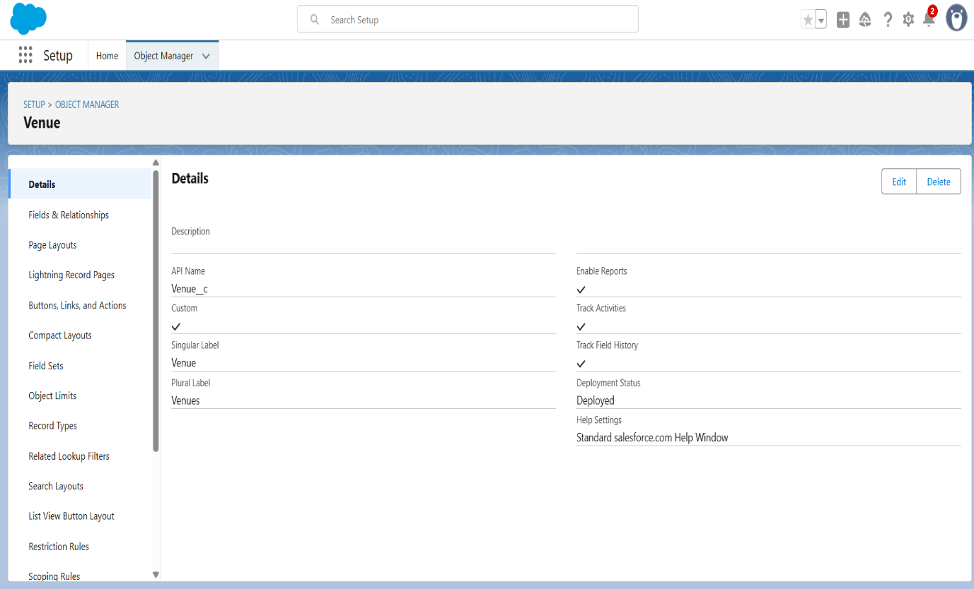

**Core Fields in Venue__c:**

* The Name field represents the official name of the venue, such as "Green Leaf Restaurant" or "Urban Food Kitchen." This is the primary identifier for users viewing or managing donation sites**.**
* The contactPhone__c field captures the contact phone number of the venue or the designated contact person, providing a quick way for volunteers or admins to get in touch
* The contactEmail__c field stores the email address of the venue contact. This can be used for automated notifications, confirmations, or follow-ups.
* The Location__c field in the Venue__c object captures the geographical position of the venue, either as a descriptive address or geolocation (latitude & longitude). It is used for mapping, calculating distances, and assigning nearby volunteers efficiently.

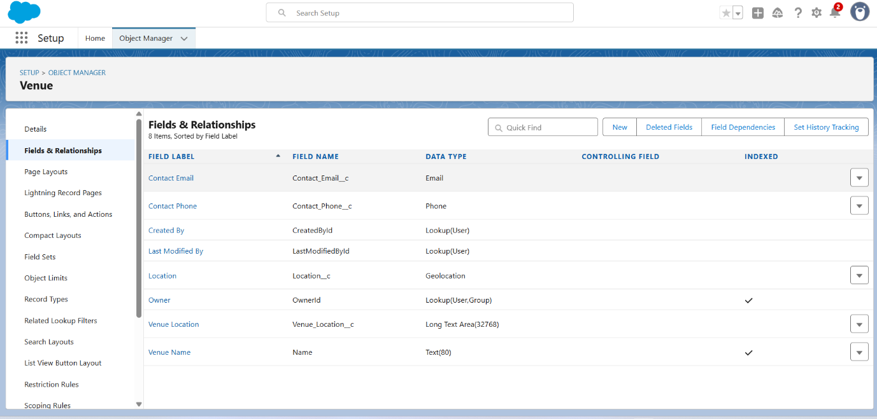

* **Drop-off point:**

The **Drop_Off_Point__c** object represents the final destination where donated food is delivered and distributed to beneficiaries. This could be an NGO center, a shelter, a community kitchen, or a designated distribution zone. It stores key details such as the location name, address, contact person, and operating hours. The object helps volunteers identify where to deliver food, ensures proper tracking of deliveries, and supports reporting on how food is being distributed. It also plays a vital role in routing, region-based assignments, and auditing successful handovers of donations.

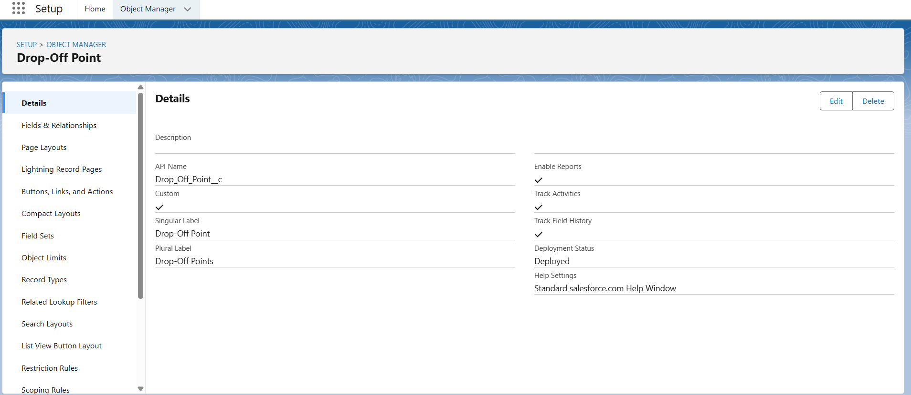

Core Fields in Drop-off point:

* **Distance__c***(Number14,4)*  
  This field stores the numerical distance (in kilo meters or miles) between the food donor venue and the drop-off point. It helps optimize delivery routes and assign the nearest drop-off location.
* **distance_calculation__c***(Formula-Number)*  
  A calculated field that dynamically computes the distance between two geolocations (e.g., donor venue and drop-off point) using Salesforce geolocation formulas. It ensures real-time distance updates based on location changes.
* **Name***(Text80)*  
  This is the name or identifier of the drop-off point, such as “Hope Shelter Center” or “Community Food Hub – Sector 10.” It serves as the primary label for the record.
* **Location_2__c***(Geolocation)*  
  Stores the precise geographic coordinates (latitude and longitude) of the drop-off point. It's used for mapping, calculating distances, and assigning delivery tasks.
* **OwnerId**  
  Represents the record owner (typically an admin or volunteer coordinator). This user or group is responsible for managing the drop-off point.
* **State__c** *(Picklist)*  
  Specifies the state or province where the drop-off point is located. It helps with region-based filtering, volunteer assignments, and reporting.
* **Venue__c**   
  This lookup links the drop-off point to the related venue where the food originated. It establishes a relationship for tracking the full delivery chain from donor to distribution point. 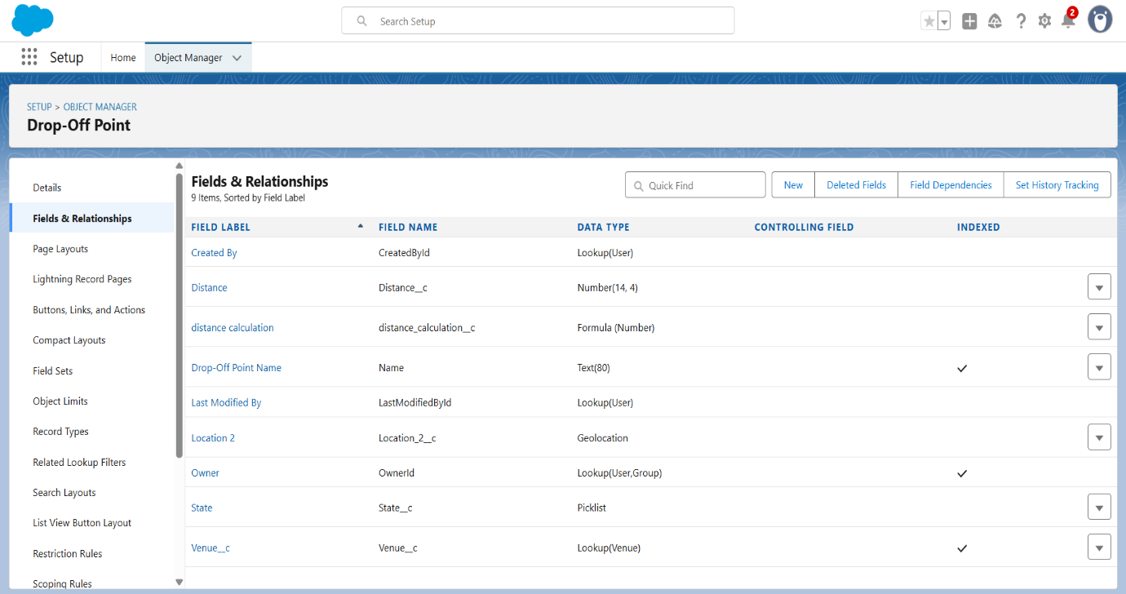
* Task:

The purpose of the **Task** object in the Food Connect project is to manage and track important activities related to the food donation process, such as scheduling pickups, assigning volunteers, and following up with donors or drop-off points. It ensures that every step in the donation and delivery workflow is organized, monitored, and completed on time.

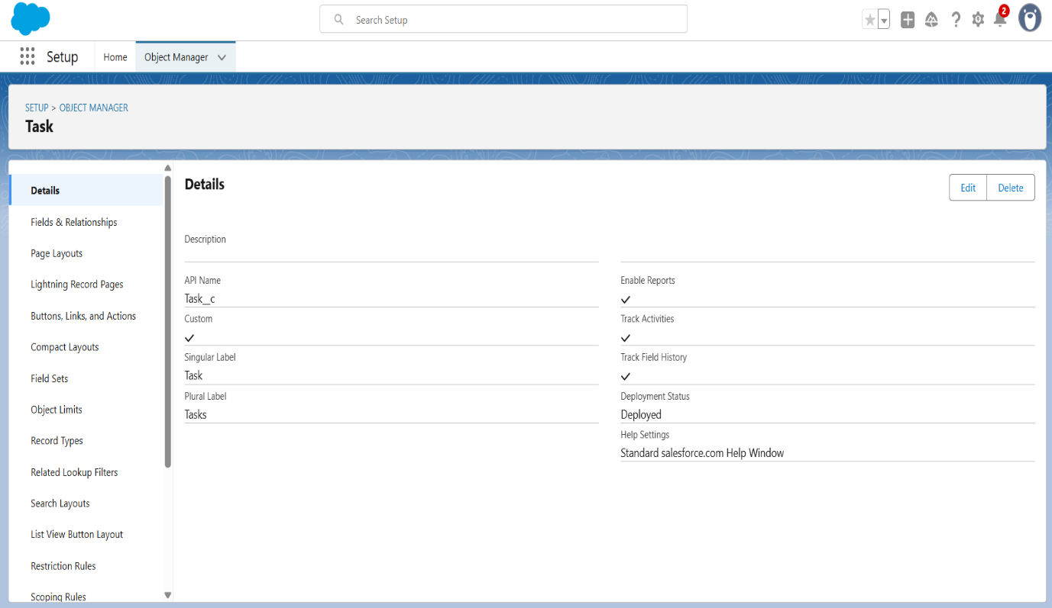

Core Fields in Task:

* **Name_of_the_Person__c***(Text18)*  
  Stores the name of the individual involved in the task—this could be the donor, volunteer, or person receiving the food. It helps personalize records and track human-level interactions.
* **Number_of_People_Served__c***(Number18,0)*  
  Captures the total number of beneficiaries who received food through this task. This field is essential for impact measurement and reporting.
* **Phone__c***(Phone)*  
  Stores the contact number of the person associated with the task, useful for follow-ups, confirmations, or resolving delivery issues.
* **Rating__c***(Picklist)*  
  Allows volunteers or beneficiaries to rate the quality of the task or delivery (e.g., Excellent, Good, Average, Poor). This helps evaluate service quality and gather feedback.
* **Task_ID__c***(AutoNumber)*  
  Automatically generates a unique identifier for each task record. It helps in referencing, sorting, and searching task logs consistently.
* **Venue__c**

Links the task to a specific venue where the activity took place or originated. This relationship helps track the origin of donations and supports location-based task management.

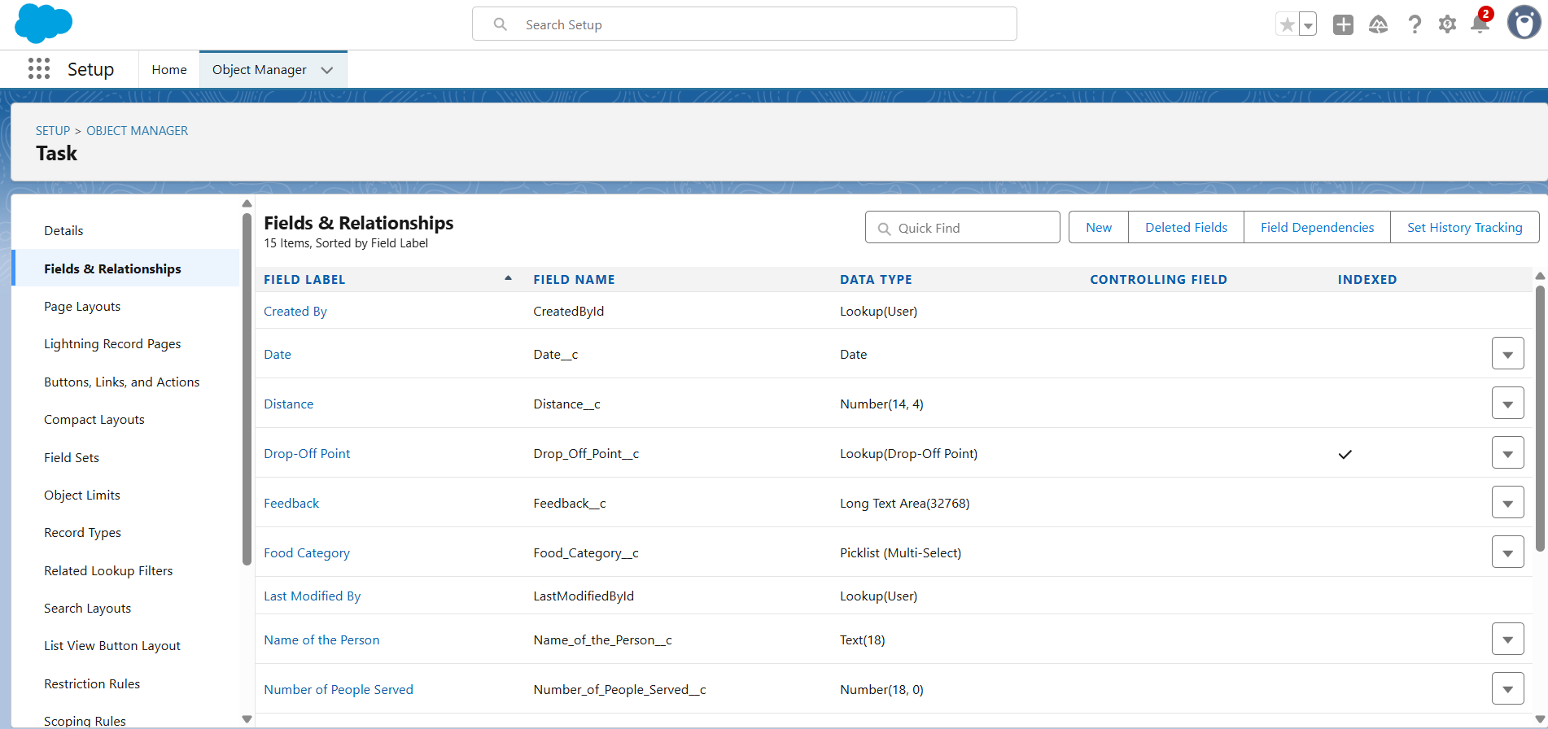

* Volunteer:

The **Volunteer__c** object represents individuals who assist in picking up and delivering leftover food from donors to drop-off points or beneficiaries. Its primary purpose is to manage and organize the network of volunteers by storing their contact details, availability, regions they operate in, and tasks assigned to them. This object enables the system to automatically assign suitable volunteers to donation pickups based on their location and availability. It also helps track volunteer performance, monitor delivery completion, and maintain communication. Overall, the Volunteer object ensures efficient coordination and accountability in the food distribution process.

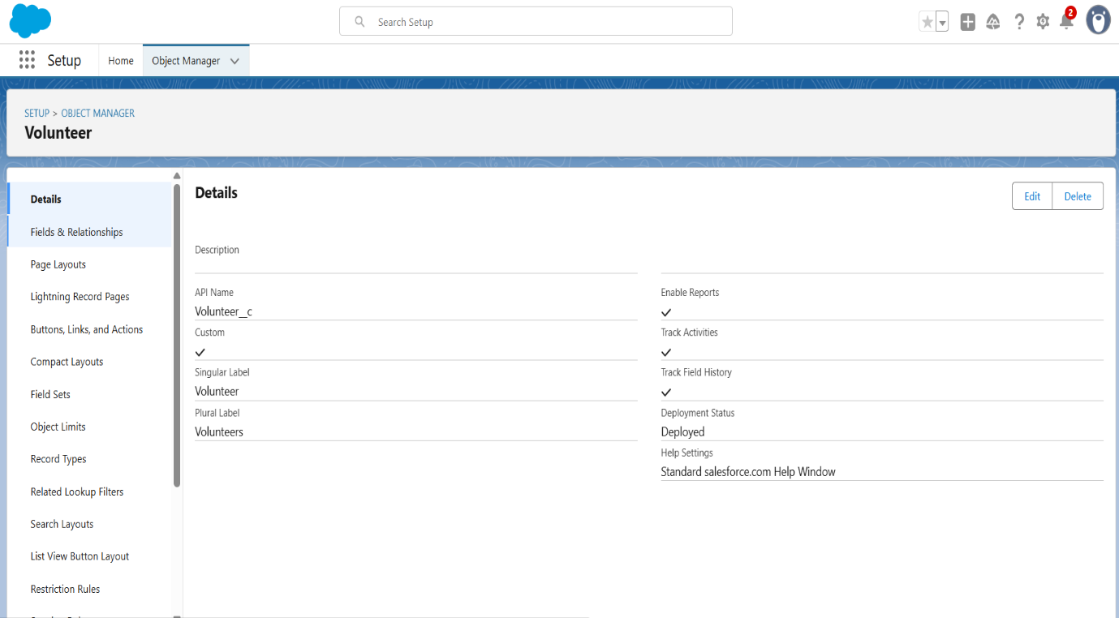

Core Fields in Volunteer:

* **Address__c***(LongTextArea)*  
  Stores the full residential or operating address of the volunteer. This helps in regional task assignments and communication planning.
* **Age__c***(Number)*  
  Records the age of the volunteer. This may be used for eligibility checks or age-based categorization of volunteer roles.
* **Available_On__c***(Date)*  
  Captures the date when the volunteer is available for assignments. It supports real-time task allocation and planning based on availability.
* **Contact_Number__c***(Number)*  
  Stores the mobile or phone number of the volunteer for coordination, alerts, and follow-ups during food pickup and delivery.
* **Date_of_Birth__c***(Date)*  
  Stores the date of birth of the volunteer. This may be used for age verification, generating birthday alerts, or volunteer segmentation.
* **Email__c***(Email)*  
  Captures the volunteer’s email address. It is used for sending confirmations, updates, and system notifications.
* **Gender__c** (Picklist)  
  Captures the volunteer's gender (e.g., Male, Female, Other). It may be used for demographic reporting or to comply with diversity and inclusion policies.
* **Volunteer_ID__c** (Auto Number)  
  A system-generated unique ID for each volunteer. It helps in consistent referencing, especially in reports and integrations.

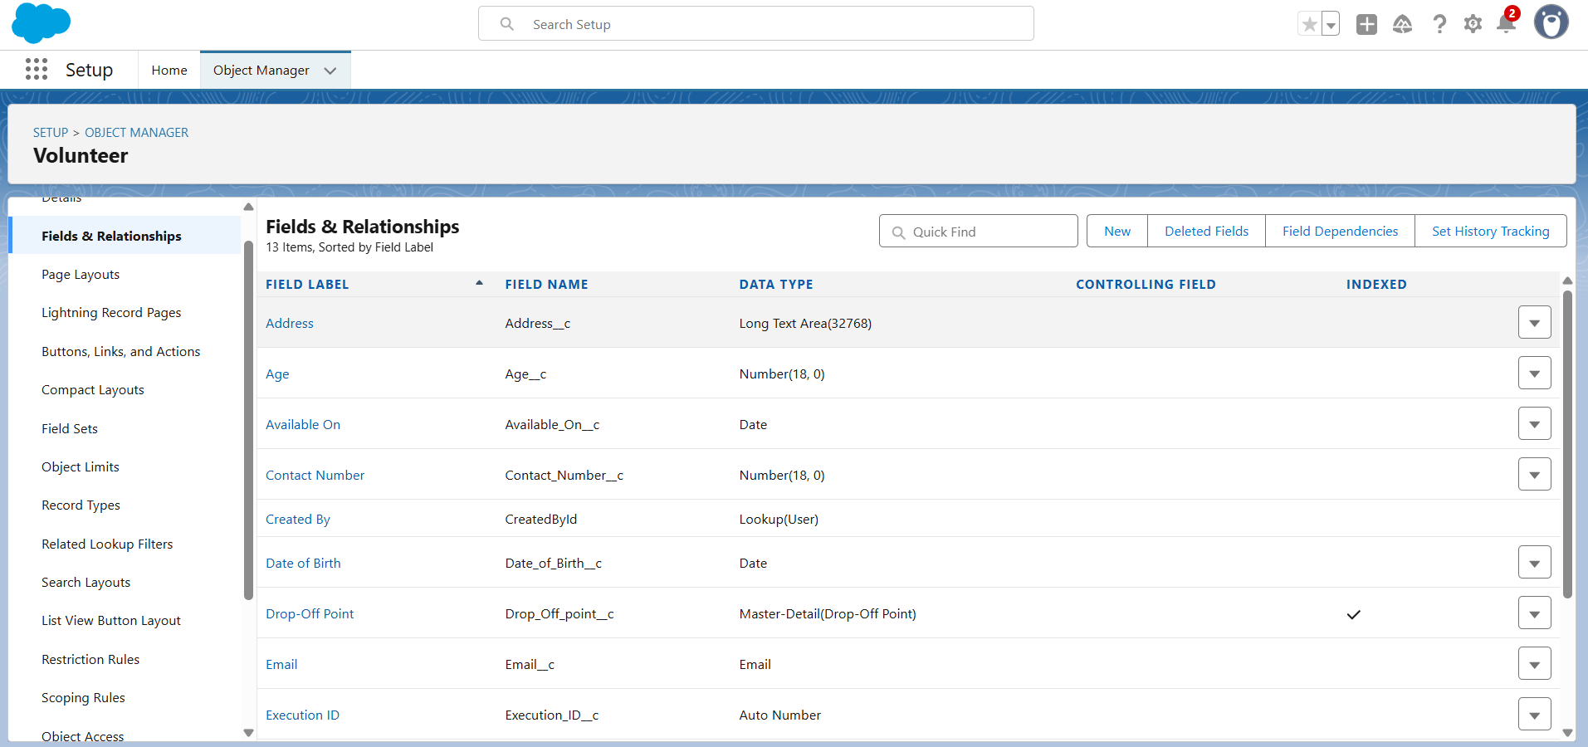

* Execution Details:

The **Execution_Details__c** object captures the real-time completion details of food pickup and delivery activities. It records key information such as the volunteer who carried out the task, the venue where the food was collected, the drop-off point where it was delivered, and metrics like the quantity of food and the number of people served. This object ensures transparency, accountability, and accurate tracking of each donation cycle. It plays a vital role in measuring operational effectiveness and generating reports for monitoring and impact analysis.

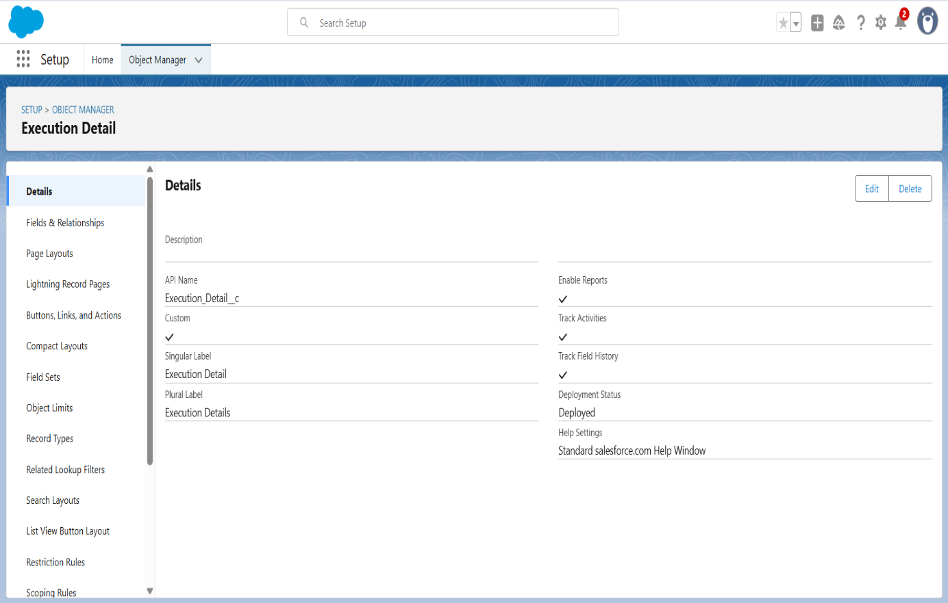

Fields in Execution Details:

* The **Execution_ID__c** field in the **Execution_Details__c** object is typically an **Auto Number** field that generates a unique identifier for each execution record. It serves as the primary reference for tracking and differentiating each completed food pickup or delivery task. This ID helps link records in reports, ensures data integrity, and simplifies auditing and operational monitoring within the Food Connect system.

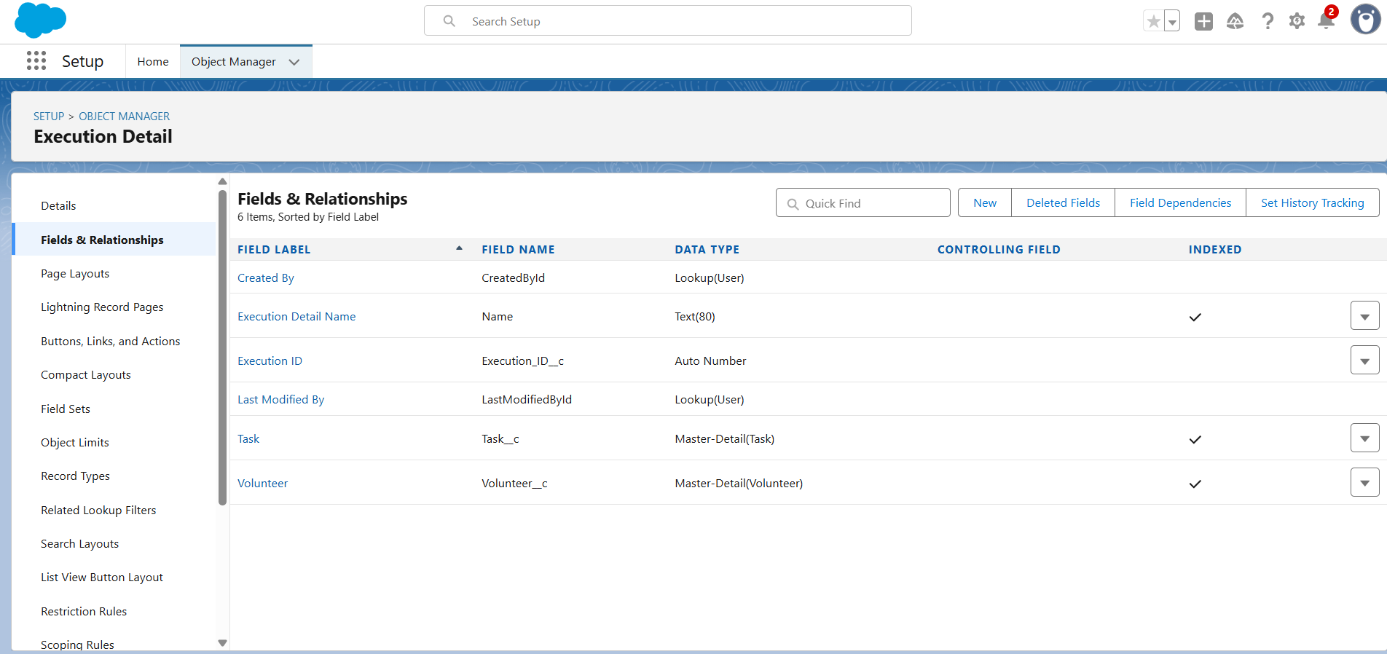

**3.Validation Rules and Automation:**

The Venue Form Flow is a custom Screen Flow implemented within the Salesforce platform as part of the Food Connect project. Its purpose is to enable streamlined and accurate creation of new Venue__c records through an intuitive, form-based interface. This flow significantly simplifies the data entry process, especially for non-technical users such as field coordinators, volunteers, and community managers. It helps ensure consistency, data integrity, and operational efficiency by guiding users through a series of input screens and automating the record creation process**.**

**Purpose:**

The main goal of this flow is to make it easy to register new food donation venues. In the traditional Salesforce interface, users must navigate complex record layouts and input fields, which may result in errors or delays. By using a screen flow, Food Connect provides a clear, step-by-step process to collect essential venue information. This not only reduces training requirements but also ensures that all necessary data points—such as name, location, and contact information—are captured in a structured and standardized manner.

This flow contributes to:

* Operational Efficiency: Automates manual data entry.
* User Empowerment: Enables volunteers and staff to create venue records independently.
* Data Accuracy: Reduces chances of missing or incorrect fields.
* Scalability: Facilitates faster onboarding of new donation venues.

### **Working Mechanism:**

When users launch the flow (either from a button or utility bar), they are presented with a clean form asking for venue details. Once the form is filled out and submitted:

* The flow processes the input.
* A new record is automatically created in the **Venue__c** object.
* Users receive feedback or are redirected (optional setup).

This approach eliminates the need for users to manually find and fill in venue record pages, reducing the risk of data inconsistency and saving time.

**Business Value and Outcome:**

The Venue Form Flow directly supports Food Connect’s mission of streamlining food donation logistics by making the process of onboarding new venues both fast and reliable. With this automation in place:

* Volunteers can quickly register new donation points in the field.
* Admins can ensure that location data is accurately captured for future delivery routing.
* All relevant fields are consistently populated, supporting reporting and analytics.

This flow is a cornerstone of the user-friendly, scalable architecture of the Food Connect CRM system.

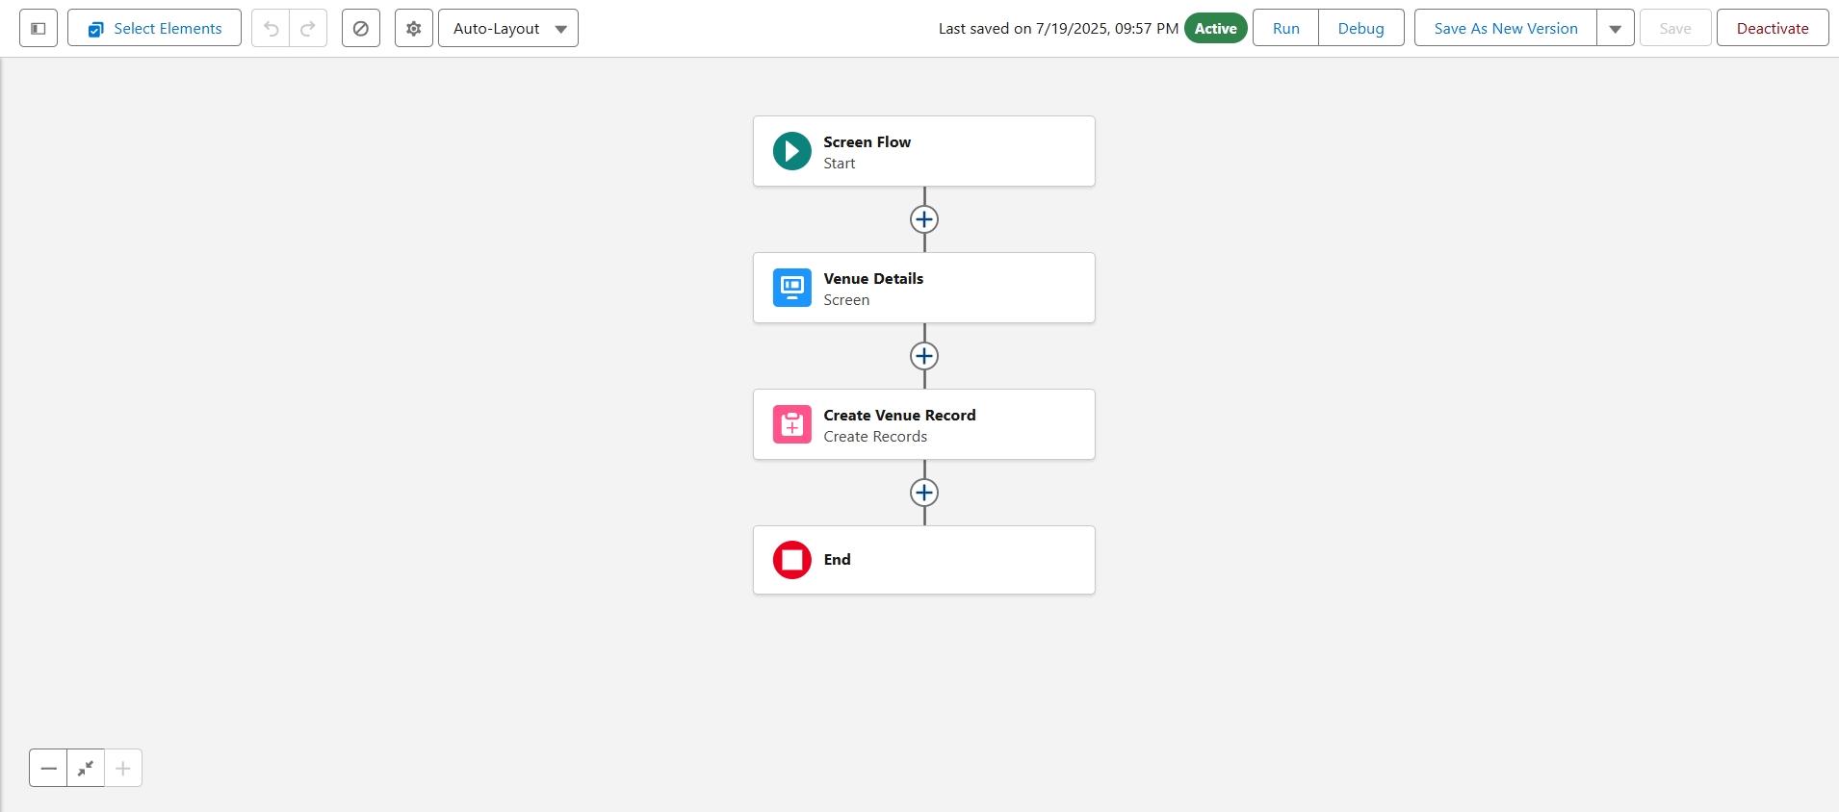

**Triggers:**

A Trigger in Salesforce is a piece of Apex code that executes before or after specific data manipulation events occur on a particular Salesforce object. These events include operations like insert, update, delete, undelete, etc.

Triggers are used to automate complex business logic at the database level, allowing you to respond immediately when records are created, modified, or removed.

**Purpose:**

The purpose of triggers in Salesforce is to automate custom business logic at the database level, allowing developers to execute specific actions automatically when records are inserted, updated, deleted, or undeleted. Triggers are particularly useful when point-and-click tools like Flows, Validation Rules, or Process Builder are not sufficient to meet complex requirements. They enable real-time enforcement of rules, data validation, and updates across related objects, ensuring consistency and integrity within the system. Triggers also support bulk operations, making them ideal for handling large-scale data changes efficiently. In essence, triggers serve as a powerful backend mechanism to streamline operations, maintain data accuracy, and support advanced workflows that go beyond declarative automation tools.

**Creating the Apex Trigger: DropOffTrigger**

To implement backend automation in Salesforce for the Drop-Off Point object, an Apex Trigger named DropOffTrigger is created. This trigger will allow developers to execute custom logic when records related to drop-off points are inserted, updated, or deleted.

**Working:**

The DropOffTrigger is an Apex Trigger created on the custom Drop-Off Point object in Salesforce. Its primary role is to execute automated backend logic in response to events such as record creation (insert), modification (update), or deletion (delete) on Drop-Off Point records. Here's a breakdown of how it functions:

1. Trigger Declaration:  
   The trigger is defined with specific event contexts like before insert, after insert, before update, after update, etc. This tells Salesforce when to execute the trigger logic.
2. Event Listening:  
   When a user or system action causes a Drop-Off Point record to be added, changed, or deleted, Salesforce automatically checks if any trigger is associated with the object.
3. Trigger Execution:  
   If DropOffTrigger is defined for that event, it is invoked automatically. For example:
   * Before Insert: Validate or modify field values before the record is saved.
   * After Insert: Create related records or send notifications.
   * Before Update: Check for business rule violations or auto-correct data.
   * After Update: Log changes or trigger updates to other objects.
   * Before Delete / After Delete: Prevent deletion if criteria aren't met or clean up related data.
4. **Access to Trigger Context Variables:**  
   Inside the trigger, Salesforce provides special variables like Trigger.new, Trigger.old, Trigger.isInsert, and Trigger.isUpdate that hold data about the current operation and affected records.
5. **Custom Logic Execution:**The developer writes Apex code inside the trigger body to define what actions should occur — such as calculating distances, updating states, or syncing with related Venue records.
6. **Bulk Safe Handling:**  
   Triggers can process multiple records at once, ensuring they work efficiently even during mass data operations like data imports or batch updates.

In Summary, The DropOffTrigger is an Apex trigger created on the **Drop-Off Point** object in Salesforce to automate backend processes whenever a record is inserted, updated, or deleted. It works by automatically executing predefined logic based on specific data events. For instance, when a new Drop-Off Point is added, the trigger can validate input fields, populate default values, or initiate related actions. If a record is updated, the trigger can monitor changes and enforce business rules or update linked records like Venue or Volunteer. Salesforce provides context variables such as Trigger.new and Trigger.old to access current and previous record values, allowing the trigger to react dynamically. Additionally, since triggers are bulk-safe, they efficiently handle multiple records during data imports or batch operations. Overall, DropOffTrigger helps maintain data integrity, automate complex workflows, and support seamless operations within the Food Connect project without requiring manual intervention.

**Working of Trigger Code:**

The DropOffTrigger is a **"before insert"** Apex trigger that runs just before a new Drop-Off Point record is saved to the database. Its purpose is to automatically set the value of the custom field Distance__c to match the value in the formula field distance_calculation__c. This is useful for scenarios like defining criteria in **sharing rules**, which do not support formula fields directly. Since the Distance__c field is a standard number field, this trigger ensures that it carries the correct, up-to-date distance value at the time of record creation. By doing this in the **before insert** context, the value is saved along with the record, making it accessible for filters, reporting, and security logic like row-level sharing. The trigger loops through each new record (Trigger.new) and copies the value from the calculated formula field to a standard editable field, ensuring consistency and usability throughout the system.

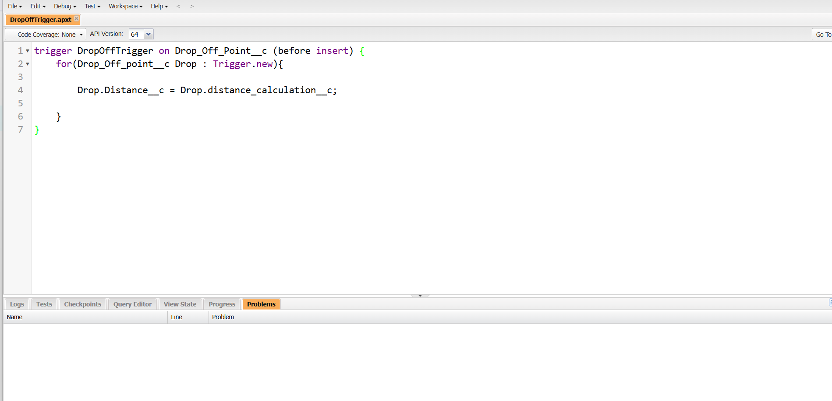

**UI/UX Development & Customization**

The **UI/UX customization** in the Food Connect Salesforce project was implemented to create an intuitive, user-friendly, and role-specific interface that supports smooth interaction with the system’s core features. The goal was to enhance the user experience for all stakeholders, including administrators, volunteers, and coordinators, by designing clean, functional layouts and user journeys that are easy to navigate and visually clear.

This customization involved configuring **Lightning Apps** to group related functionalities under one interface, setting up **page layouts and dynamic forms** to ensure users only interact with relevant fields based on their role or the stage of a process, and applying **Lightning Record Pages** with standard and custom components for a rich, modular experience. Thoughtful UI elements like sectioned forms, highlight panels, and conditional visibility reduced clutter and guided users effectively.

In addition, **user access and profiles** were tailored so that each type of user only sees what’s necessary, which not only improved usability but also strengthened data security. Enhanced visuals through **Dashboards** and **Reports** gave a clear overview of donation activities.

**Lightning App:**

Creating a Lightning App Page in Salesforce allows you to build a tailored, user-specific interface to streamline navigation and provide quick access to core objects and functionalities. The process ensures that users can access the tools and data they need efficiently, enhancing productivity and user experience.

This Lightning app will be used to manage critical operations in the Food Connect project, where users will have easy access to objects like Venue, Drop-Off Point, Task, Volunteer, and Execution Details through an intuitive interface.

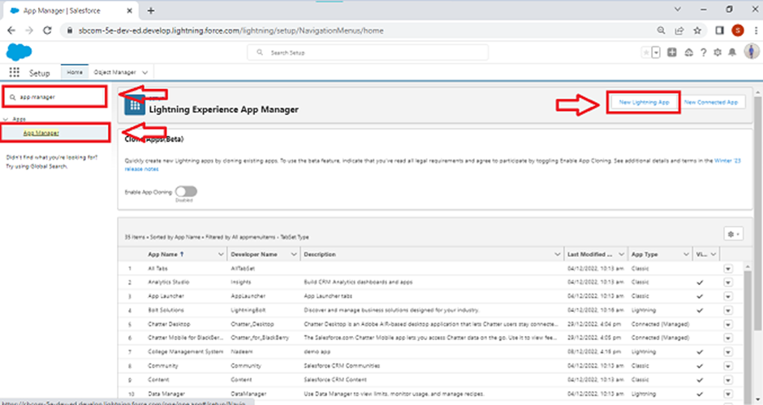

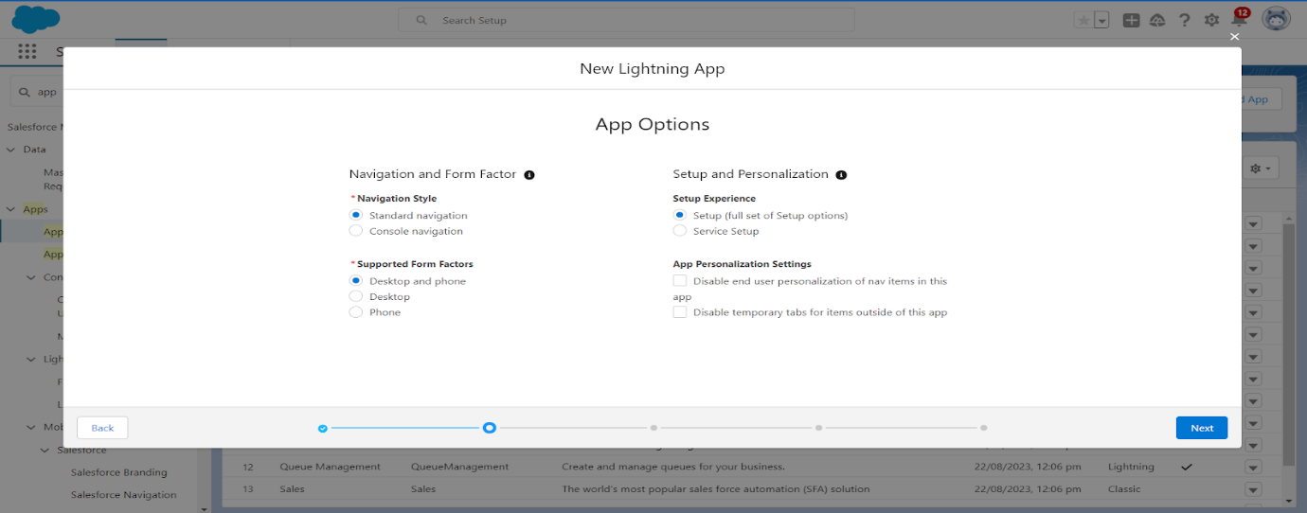

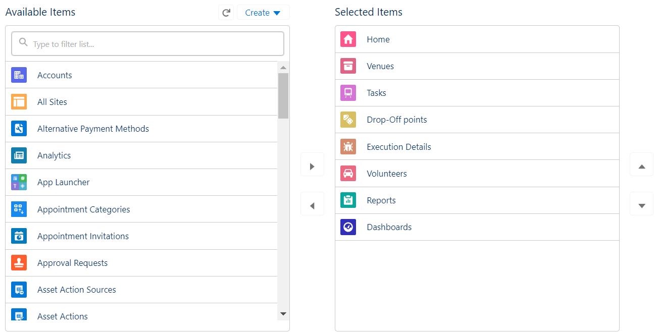

**Purpose and Benefits:**

1. Centralized Access to Core Objects:

By setting up a Lightning app, you provide users with a one-stop interface to access key objects like **Home**, **Venue**, **Drop-Off Point**, **Task**, and others. This removes the need for navigating across multiple pages or tabs, making the process smoother.

2. Role-Based Navigation:

You can set up personalized views and navigation items based on user profiles (e.g., **System Administrator**, **Coordinator**, etc.), ensuring users see only the information relevant to their role.

3.Improved User Experience:

With customizable navigation items, color branding, and optional images, the app is designed to align with the needs of the Food Connect project, improving usability and making the system more intuitive for non-technical users.

**Working:**

This Lightning app provides a dedicated interface for users working within the Food Connect project. The app is set up with core objects like Venue, Drop-Off Point, and Volunteer as primary navigation items. After completing the setup, users can access these objects directly from the app's sidebar, without having to navigate through multiple Salesforce pages. The role-based profiles ensure that only the necessary data and features are available to each user, making the app efficient and user-friendly.

This streamlined navigation and easy access to essential data empower users to manage food donations, volunteers, and drop-off points quickly, improving the overall workflow of the Food Connect project.

**Reports:**

Reports play a vital role in providing real-time insights, performance tracking, and operational transparency. Reports allow stakeholders—such as administrators, coordinators, and donors—to monitor and analyze data related to food donations, volunteer activity, task completion, and drop-off point performance.

The purpose of these reports is to transform raw data into meaningful visual summaries that support informed decision-making. For instance, administrators can quickly generate reports to assess how many meals have been served in different states, track the availability and contributions of volunteers, or identify which venues frequently donate food. These insights can guide logistical planning, highlight bottlenecks, and ensure that resources are allocated efficiently.

**Working:**

The “Venue and Drop-Off Point” report is designed to provide a consolidated view of the relationship between venues, drop-off points, and volunteers. The report is created by first navigating to the Reports tab within the app and organizing it under a new folder labeled “Custom Reports”. A new report is then generated using the report type “Venue with Drop-Off with Volunteer”, which pulls together data from three interconnected objects: Venue, Drop-Off Point, and Volunteer. Within the report builder, the data is grouped by Volunteer Name to show which individuals are responsible for handling deliveries. Key columns such as Venue Name, Drop-Off Point Name, and Distance are added to provide insight into the origin and destination of donations, and the geographic distance involved.

After building the layout, the report is saved under the custom folder with the name “Venue and Drop Off Point” and executed to display live data. This report serves as a critical operational tool by allowing administrators and coordinators to monitor volunteer assignments, evaluate delivery coverage, and optimize route planning. It simplifies the task of identifying which volunteers are linked to specific venues and drop-off points and how far they must travel, helping to ensure a more efficient and balanced food distribution system. Additionally, it enhances transparency and decision-making by offering a clear, organized view of backend logistics within the Food Connect project.

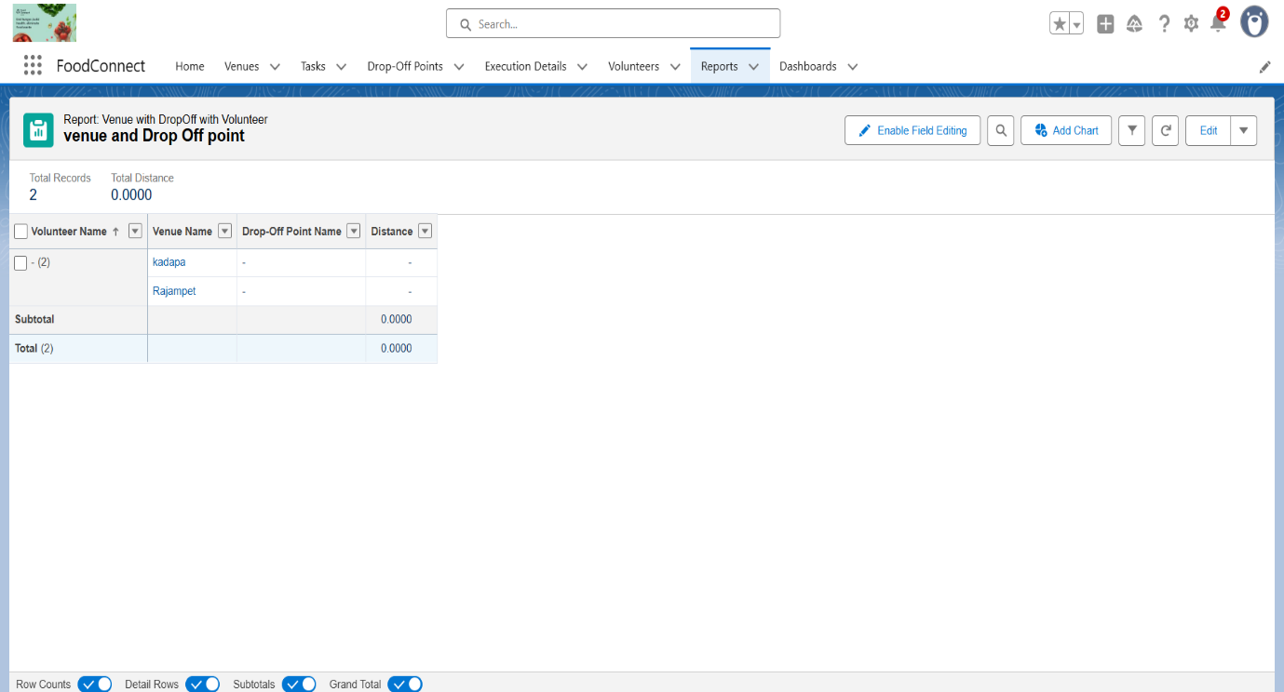

The **"Volunteer Task"** report is created to monitor and evaluate the activities and performance of volunteers by linking their data with execution details and assigned tasks. To generate this report, users first navigate to the **Reports** tab and open the **Custom Reports** folder, ensuring all related project reports are stored in one organized location. A new report is then initiated by selecting the report type **"Volunteers with Execution Details and Tasks"**, which enables the system to pull information from three interconnected objects—**Volunteer**, **Execution Details**, and **Task**.

Once inside the report builder, the data is grouped by **Volunteer ID**, allowing for a segmented view of each volunteer's contributions. Several key columns are then added: **Volunteer Name** provides the volunteer’s identity, **Task Name** shows the task assigned, **Execution Detail Name** gives insight into the execution process linked to the task, **Owner Name** identifies the user responsible for managing the volunteer, **Task Date** records when the task was carried out, and **Task Rating** reflects the performance or outcome quality of the task. This comprehensive set of data points enables effective performance tracking.

After the structure is finalized, the report is saved and executed with the name **"Volunteer Task"**, and placed in the **Custom Reports** folder. This report becomes a valuable operational tool for coordinators, as it allows them to review which volunteers are active, what tasks they have completed, how those tasks were executed, and how their work is rated. The insights gathered from this report assist in recognizing top-performing volunteers, reallocating resources, and making data-driven improvements to the food donation and distribution process.

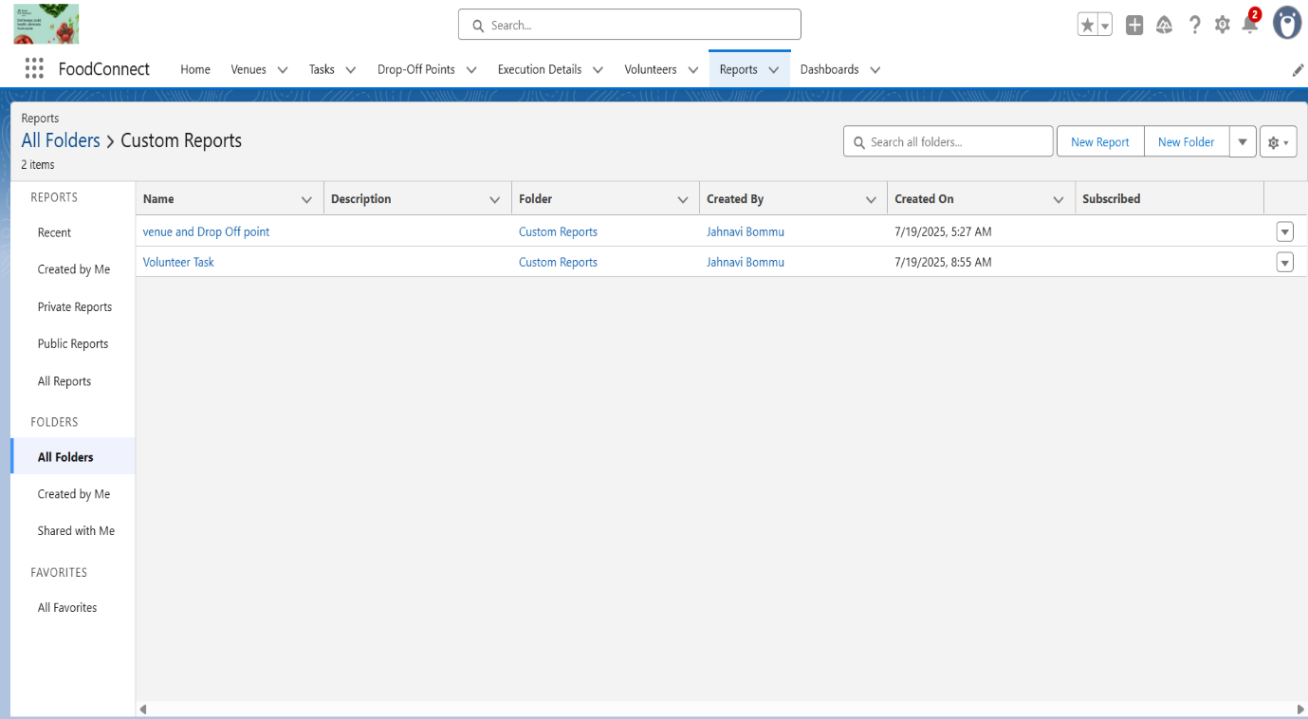

**Dash Boards:**

Dashboards are powerful visual tools that provide real-time, at-a-glance summaries of key metrics and reports. They are built on top of reports and serve as a central visual interface for tracking the system’s performance, engagement, and efficiency across multiple operations such as food distribution, volunteer management, task execution, and venue activity.

Dashboards in Food Connect were created to give administrators, coordinators, and stakeholders a consolidated view of important KPIs (Key Performance Indicators). For example, components like “Number of Tasks Completed by Volunteers,” “Food Delivered by State,” or “Venue Participation Rates” help users quickly understand how well the platform is functioning without digging into raw data.

Each dashboard includes charts, graphs, gauges, and metrics, with interactive filters to adjust views by time range, region, or volunteer. These dashboards are typically refreshed in real time or on a schedule, ensuring users always see the most recent data. They support better decision-making, quicker problem identification, and more strategic planning.

By presenting critical information in a visual format, dashboards improve transparency, accountability, and operational oversight—making them an essential element of the Food Connect app’s UI/UX design and management functionality.

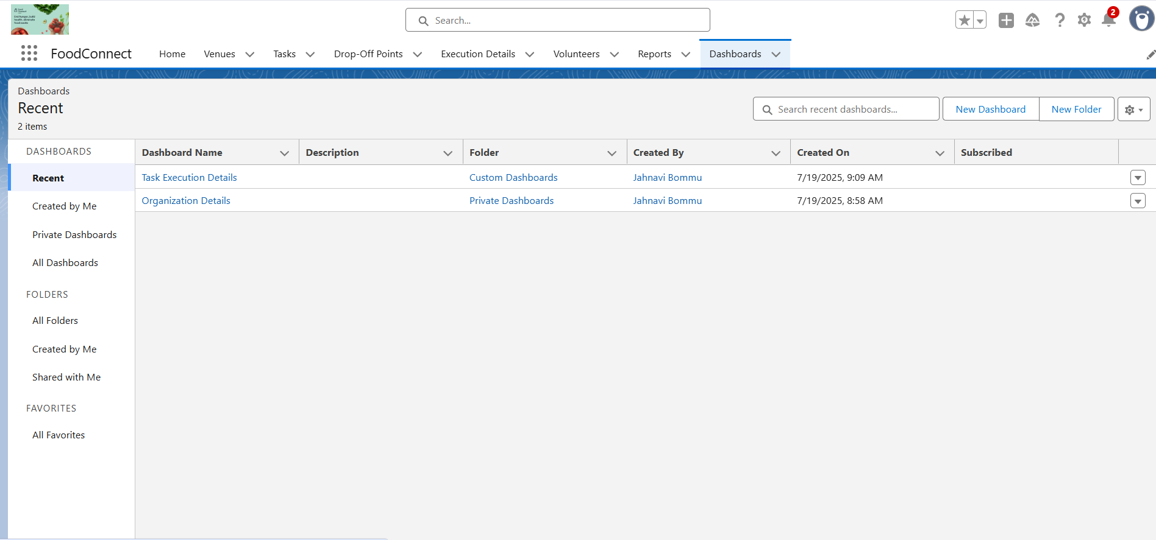

**Organization Details:**

The dashboard is named **“Organization Details”**, aimed at showcasing key relationships and logistics involving **Venues** and **Drop-Off Points**. Within the dashboard editor, the user adds a component (called a widget) and selects either a **chart** or a **table**, depending on how they want to visualize the data. The data source is selected by choosing an existing report—specifically the **“Venue and Drop-Off Point”** report created earlier. This report brings in structured data about the flow of donations from venues to drop-off points along with distance and volunteer information.

In the component configuration settings, the **display style** is set to **Lightning Table** for a clean tabular view, and the **theme** is optionally set to **Dark** for a modern look. Once all configurations are complete, the user clicks **Save**, and the new dashboard becomes immediately available for viewing and interaction.

This dashboard allows coordinators and admins to visually interpret complex report data, track operational efficiency, and quickly identify gaps or high-performing areas within the FoodConnect system. By summarizing data into an interactive and visually compelling layout, it enhances decision-making and supports smooth day-to-day operations.

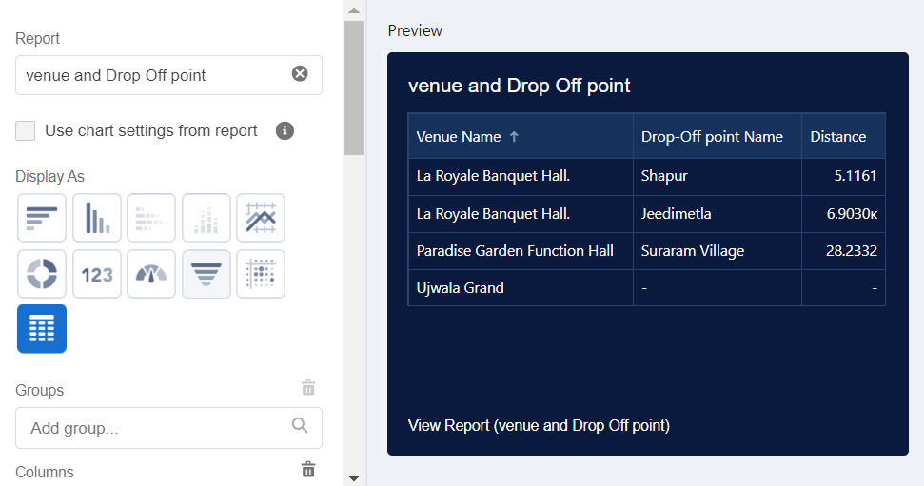

**Volunteer Task:**

To further enhance visibility into volunteer performance and task execution, an additional component is added to the **“Organization Details”** dashboard using the **“Volunteer Task Report”** as the data source. This step provides a visual representation of how tasks are distributed across volunteers over time.

To do this, users return to the **Dashboard Editor** under the **Custom Dashboards** folder. Within the **“Organization Details”** dashboard, a new **widget** (also called a dashboard component) is added. The user selects either **Chart** or **Table**, and then chooses the report titled **“Volunteer Task”**, which contains key information such as volunteer names, task names, task dates, and ratings.

Once the report is selected, the user configures the visualization style by choosing **Display As: Line Chart**, which is ideal for showing trends over time—like how many tasks are completed weekly or how ratings vary across volunteers. To match the style of other dashboard elements, the **Component Theme** is optionally set to **Dark**, providing a sleek, modern interface.

After configuration, the component is added and saved within the dashboard. This new line chart allows users to analyze volunteer activity patterns, assess performance trends, and make timely decisions about resource allocation and volunteer engagement strategies. It adds significant value to the dashboard by turning data into actionable visual insight.

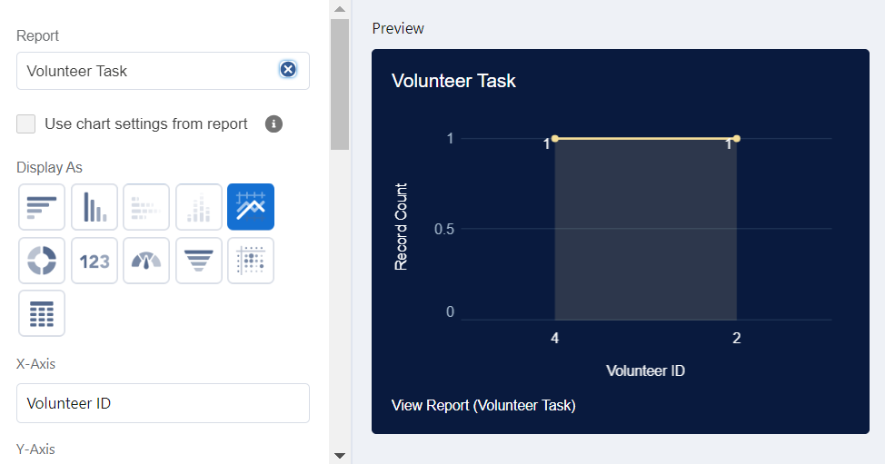

To complete the customization of the **Food Connect** dashboard with enhanced visual appeal and branding, users can **upload an image** to the dashboard interface. This is typically used to add a **logo**, **banner**, or **visual context** related to the purpose of the dashboard.

Once inside the **Dashboard Editor**, users click on the **Widget** area and choose the **Picture** component. They are prompted to **select an image file** from their local system—this could be an organization logo, a map of drop-off locations, or any relevant image that adds visual clarity or identity to the dashboard.Next, under **Select Folder**, the user selects the previously created **Custom Dashboards** folder to keep all related dashboards organized in one place.Finally, clicking **Save** confirms the changes and publishes the updated dashboard. The newly created **Task Execution Details** dashboard now includes both data visualizations (such as the Volunteer Task line chart) and custom images, providing a richer and more informative UI for managers and coordinators. This blend of visual and data elements greatly improves user engagement and compression of operational performance.

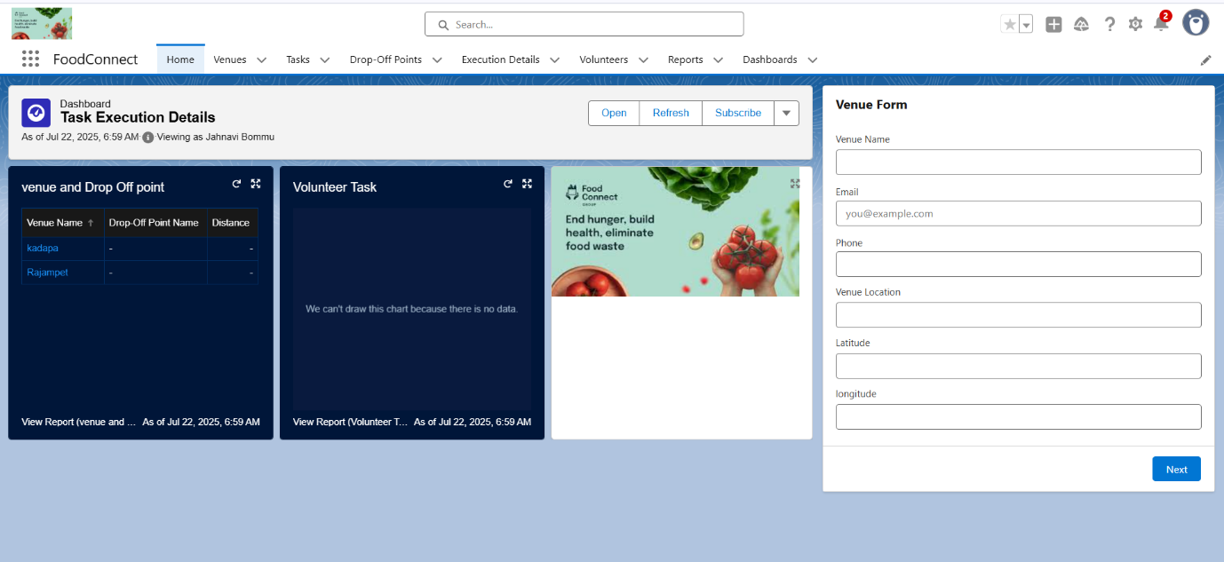

**Data Migration, Testing & Security**

**Profiles:**

The NGOs Profile was created to define a custom access level tailored specifically for users from NGOs such as the Iksha Foundation who manage food donations, volunteers, and bookings within the Salesforce system. By cloning the Standard Platform User profile, we inherited a baseline set of permissions suitable for users who need access to custom apps but not to CRM standard functionalities like leads or opportunities.

This profile controls what NGO users can see, do, and edit within the application. It includes access to custom objects like Food Donations, Bookings, Volunteer Requests, and Approvals. Permission settings were adjusted to allow read/write access to these objects, while restricting access to administrative settings or sensitive internal records not relevant to NGO users. This ensures data security, controlled access, and streamlined user experience for NGO partners, all while maintaining compliance with role-based data governance policies.

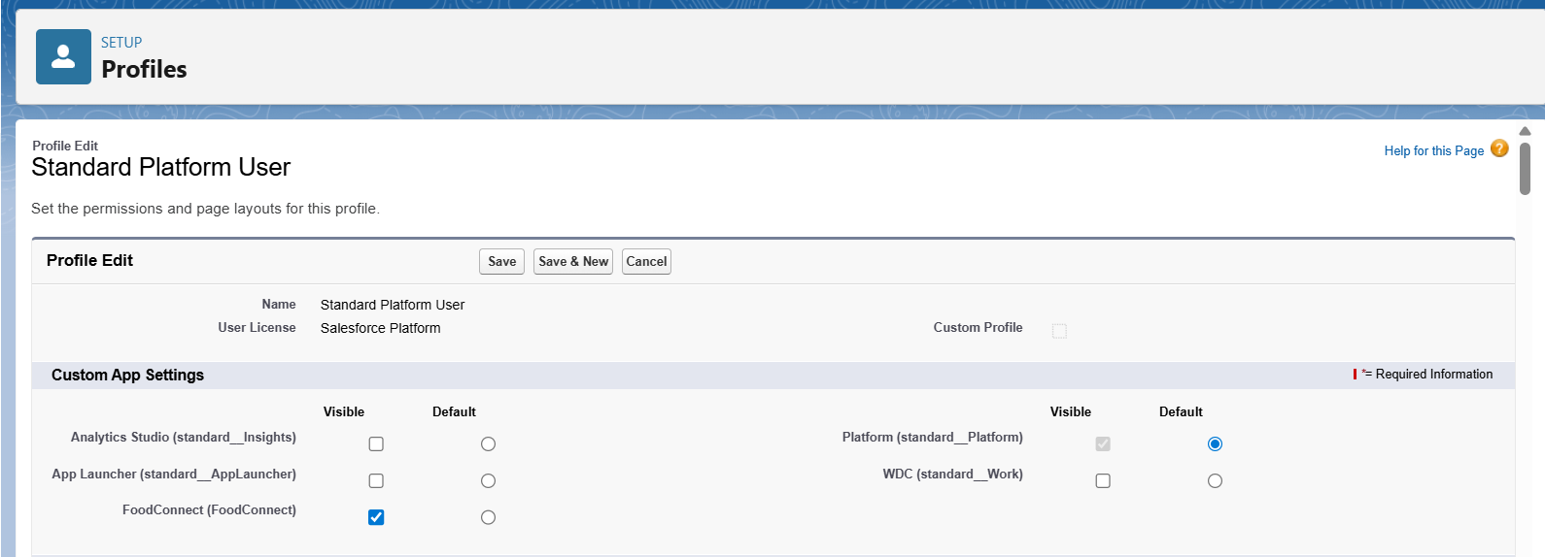

**Sharing Rules:**

In the Supply Leftover Food, sharing rules are configured to manage access to Drop-Off Point records based on geographical distance, ensuring that only relevant user groups (based on proximity) can view and manage those records. This targeted sharing enhances operational efficiency, maintains data security, and facilitates localized response from various volunteering organizations.

To achieve this, we created three criteria-based sharing rules under Drop-Off Point SharingRules. These rules were designed to share records dynamically with designated Public Groups based on the Distance field in the Drop-Off Point object.

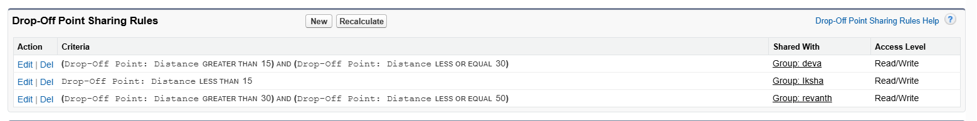

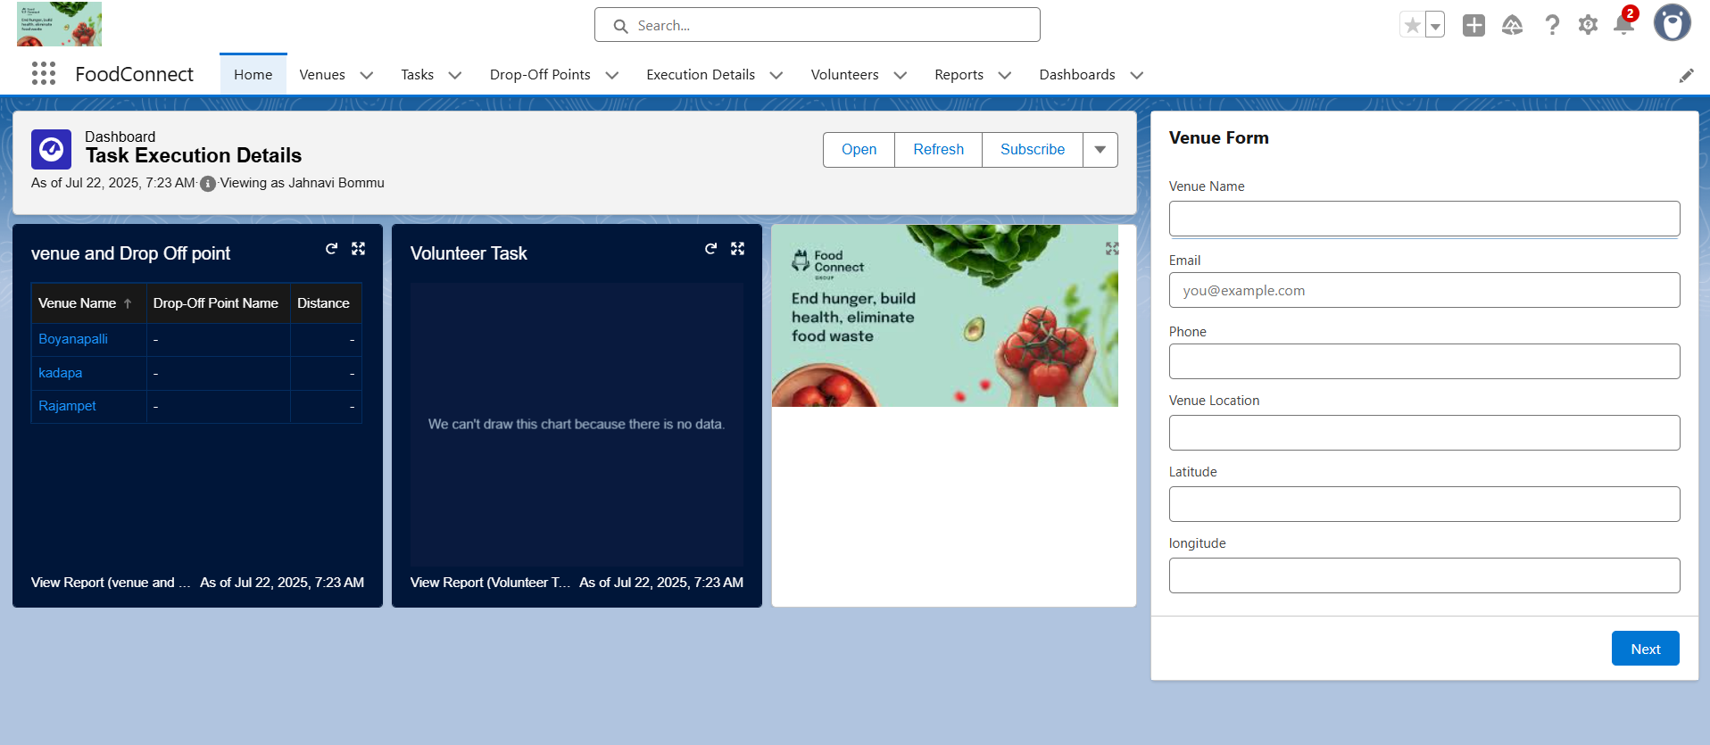

**Deployment, Documentation & Maintenance**

The deployment of the *Supply Leftover Food Salesforce CRM system* followed a structured and phased strategy to ensure a smooth and error-free transition from the development environment to production. The primary deployment method used was **Change Sets**, allowing secure transfer of metadata components such as custom objects, flows, Apex classes, validation rules, and sharing settings from sandbox to production. All components were thoroughly tested before deployment, and test classes ensured a minimum of 90% code coverage to meet Salesforce's best practices. For ongoing maintenance, the system is monitored through scheduled data backups, regular audits of user access, and performance tracking using debug logs and scheduled Apex job reviews. System health is further maintained through field history tracking, duplicate rule enforcement, and automated monitoring of flow and trigger errors. Comprehensive documentation has been prepared to support ongoing use and troubleshooting. It includes data model diagrams, user guides, component logs, and business process flowcharts. In the event of an issue, a structured troubleshooting approach is followed—starting with user input and system logs, followed by sandbox replication, root cause identification, resolution deployment, and final validation. All incidents and fixes are recorded in a centralized troubleshooting log to support transparency and continuous learning. This well-rounded deployment and maintenance strategy ensures the platform remains secure, scalable, and responsive to the evolving needs of NGOs, donors, and volunteers participating in the food distribution process.

The Salesforce system is designed with long-term stability, maintainability, and scalability in mind. The following activities ensure ongoing performance and data health:

* **Regular Data Review**:
  + Monthly validation of key objects (Donations, Bookings).
  + Duplicate management jobs run using Matching & Duplicate Rules.
* **User Management**:
  + Monthly review of active users and their roles/profiles.
  + Permission Sets updated based on user role changes.
* **Audit & Field History Tracking**:
  + Field History Tracking enabled on critical fields.
  + Admins review logs weekly for any anomalies.
* **Backup & Export**:
  + Weekly scheduled data export enabled for all major objects.
  + Metadata backups stored using Salesforce Setup > Data Export.
* **Monitoring Automation**:
  + Email alerts configured on Flow/Process errors.
  + Triggers and Batch Classes are monitored for failure logs in **Debug Logs** and **Apex Jobs**.

**Performance Monitoring**

* Monitor **Login History** for suspicious access.
* Review **Apex Exception Logs** and **Email Deliverability Logs** weekly.
* Analyze **Storage Usage** and clean up old records/logs when necessary.

**End-User Feedback**

* Maintain a **feedback loop** using surveys or a shared Google Form to log improvement suggestions and bug reports.
* Use **Chatter groups or Slack channels** for real-time issue escalation.

**Conclusion:**

The Food Connect project successfully harnesses the power of Salesforce CRM to create a centralized, intelligent, and scalable platform for managing the donation and distribution of leftover food. By integrating NGOs, food donors, volunteers, and logistics partners into a unified system, the solution ensures that surplus food is redirected efficiently to those in need, reducing waste and addressing hunger at the community level.

Through thedevelopment of custom objects, automated approval processes, record-level sharing rules, and distance-based volunteer assignment, the platform brings operational transparency and speed to a traditionally manual and fragmented process. Critical functionalities such as booking management, donor-volunteer coordination, and task automation have been implemented using Salesforce Flows, Apex triggers, and validation logic, backed by robust profiles, roles, and permission sets to ensure data security and user-specific access.

The deployment strategy using Change Sets ensured a stable rollout, while extensive documentation and a proactive maintenance model were established to support long-term system integrity and adaptability. By incorporating field tracking, automated alerts, and performance monitoring, the system is built to evolve with future organizational needs.

In conclusion, the Food Connect platform is a digital bridge between food surplus and hunger relief. It stands as a testament to how cloud-based technology and thoughtful system design can contribute meaningfully to social impact—enabling NGOs to act faster, scale farther, and serve communities more effectively.

**Top of Form**

**Bottom of Form**

•